Porter County Soil & Water Conservation District
65th Annual Meeting
Thursday, March 8, 2018
Prince of Peace Lutheran Church Hall
234 W. Division Rd.
Valparaiso, IN
6:30 pm
Three entrée buffet with dessert
Tickets-$10
Call the Soil & Water Office @ 219-462-7515 or E-mail michelle.benson@in.nacdnet.net for ticket information.

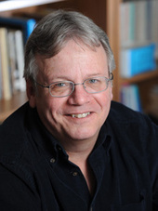
Featured Speaker
Dr. Mark Schurr,
Department of Anthropology University of Notre Dame

From his website:

Since 2003, Schurr has led archeological digs on the grounds of the Collier Lodge, a 19th-century hunting lodge located on the banks of the Kankakee River in northwestern Indiana. With the help of Notre Dame anthropology students and volunteers from the Kankakee Valley Historical Society, Schurr has unearthed hundreds of clues to the area’s rich past, including a prehistoric tool dating to 7,000 B.C., beads, tools and dishes of prehistoric Native American tribes, parts of a rare flintlock rifle, a spear point that dates back to 300 B.C., and prehistoric pottery from every known time period, spanning 800 B.C. to imported English pottery of the early 19th century. “Because the site had never been plowed, layers of earth were sealed, revealing centuries of artifacts," Schurr said. "I have never seen another site like this.”

